Proposed template for the ICSAAM 2018 Conference in Tarbes
Olivier Pantalé¹ and Olivier Dalverny¹
¹Laboratoire Génie de Production, ENI de Tarbes, France
Abstract
T
his is a template for the submission of an abstract for participation in the ICSAAM 2018 conference (8th Intenational Conference on Structural Analysis of Advanced Materials) to be held from 28 to 31 August 2018 at the "Ecole Nationale d’Ingénieurs de Tarbes" in France. This sample document contains the main lines of the author’s instructions. The abstract length must be 2 to 3 pages length, including figures, tables and references.
Keywords: Mechanics, Finite Element Method, Computational Mechanics
- Format of the abstract
The abstract format corresponds to this document. Templates are available on the conference website in two different formats: a Latex template (in the form of an editable .tex file) and a Microsoft Word document (.docx file). The submission of an abstract on the site is done only in PDF format, whatever the initial file used. No other document format will be accepted.
In the submission of the document, it is requested to respect the proposed template, and in particular, the blank area at the top of the first page of the document (in which the conference logo will be added at the time of publication of the abstract collection). Likewise, it is important not to number the pages as page numbers will be added when creating the abstract collection.
Equations present in the document should be inserted using the following formalism:
 | $$f\left(x\right)=\int_{x}{\left[\left(x+a\right)\left(x+b\right)\right]}dx$$ | (1)
Tables and figures in the document should be inserted using formalism presented in Table 1 and Figure 1. Bibliographical references [1, 2] (limited to a maximum of 5 references) should be referenced in the text using the formalism used in this sentence and included at the end of the document in accordance with the format proposed in this document.
Table 1: Example of a table
 | Early registration | After 1st June 2018 | Friday visit
Delegate | 500€ | 600€ | 60€
Student | 300€ | 400€ | 60€
Accompanying person | 150€ | 150€ | 60€
One day registration | 150€ | 150€
Exhibitor | 1000€
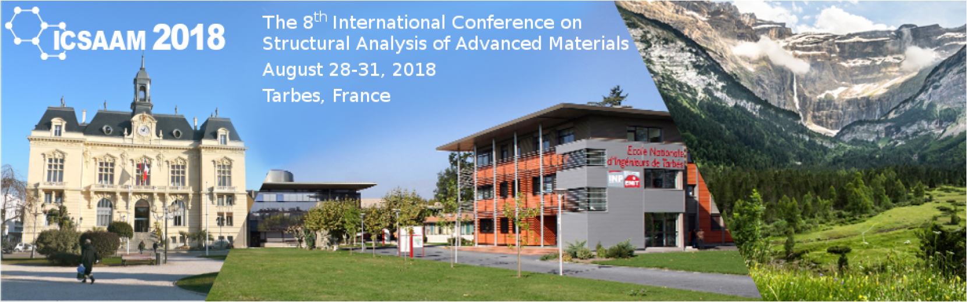
Figure 1: Example of figure
- Submission of the abstract
Abstract submission is via the online website, in PDF format only.
References
[1] Leslie Lamport, LATEX: A Document Preparation System. Addison Wesley, Massachusetts, 2nd Edition, 1994.
[2] John Doe A completely unknown publication, Never published, 2018.

